**Monument: (4) Building A**

Date: Late 4th or early 3rd century B.C.

Material: Vuggy pebbly limestone

Location: Western Hill

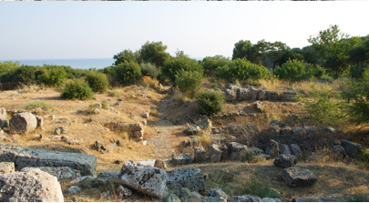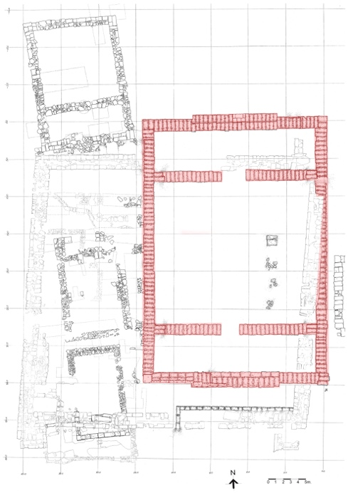

Caption: (Left) Current state photo (Right) Plan. © American Excavations Samothrace

Just west of the Milesian Banqueting Hall stand the foundations of an unfinished building that was likely begun in the late 4th or early 3rd century B.C. Had it been completed, this building would have been one of the largest in the Sanctuary. The preserved plan indicates that it was oriented north south. Colonnaded entrances set within the north and south walls gave access to shallow antechambers, which, in turn, led to a large central room measuring approximately 19 m by 21.50 m. An unfinished anta base shows that the original building was designed in the Ionic order. Foundations were also laid for two rows of interior columns to support a roof. After work was abandoned, the building remained an open platform in the Sanctuary, with marble euthynteria and a krepidoma consisting of three marble steps.

There was some investigation into Building A in the 19th century, but it was not until 1923 and 1927 that it received full attention when the French-Czech expedition conducted excavations on the building’s foundations and created a catalogue of its marble euthynteria and step blocks. Between 1965 and 1970, J. R. McCredie and the American team uncovered internal fieldstone foundations in the building’s main chamber.

Selected Bibliography:

Lehmann, K. 1998. *Samothrace: A guide to the Excavations and the Museum*. 6th ed. Revised by J.R. McCredie. Thessaloniki, p. 113.

McCredie, J. R. 1968. “Samothrace: Preliminary Report on the Campaigns of 1965-1967,” *Hesperia* 37, pp. 209-210.

–––. 1979. “Samothrace; Supplementary Investigations, 1968-1977,” *Hesperia* 48, p. 27.

Document updated: Glennon 20211120